21.98: a) 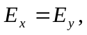and 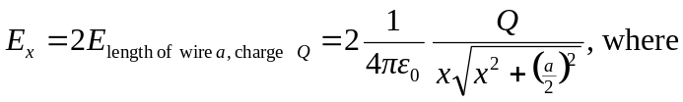
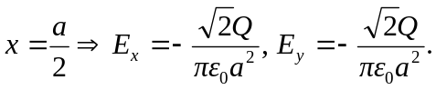
b) If all edges of the square had equal charge, the electric fields would cancel by symmetry at the center of the square.

